OFFICIAL COORDINATION REQUEST FOR
NON-ROUTINE OPERATIONS AND MAINTENANCE

COORDINATION TITLE- 13 IHR 05 Ice Harbor Temporary Unit Priority Change
COORDINATION DATE- 28 March 2013
PROJECT- Ice Harbor Dam
RESPONSE DATE- Responses are requested ASAP

Description of the problem

Main Turbine Unit #6 continued operation (based on recent oil analysis) is unreliable and will eventually trip off line due to governor issues associated with the oil. On January 17, 2013 Main Unit #6 was put in service because of the trips on other units. The unit has been being used to supplement generation and avoid spilling water over the spillway since 1/17/13. The unit was out of service prior to 1/17/13 to determine the issue with the oil in the governor system. Now that Units 2 and 3 are starting to be returned to service, it is the desire of the Project as to prevent further damage to unit 6, to run this unit last in priority until after spring run-off when the unit can be taken out of service. This will avoid elevated gas levels in the river during spring runoff.

Type of outage required

It is requested that Main Turbine Unit 6 be operated last on in Turbine Priority.

Impact on facility operation

This work expected to begin between June 1 – July 30. Unit #6 will be operated last on until repairs can be made. The current main unit priority is 1,3,6,4,2,5 and the proposed main unit priority is 1,3,4,2,5, and 6.

Dates of impacts/repairs

Repairs are to be made when river flows reduce as to not requiring Main Turbine Unit 6 operation for lowering dissolved gases as opposed to increased spill due to exceeding Powerhouse capacity of 96 kcfs.

Length of time for repairs

Repairs to the unit governor are scheduled to occur while this unit is taken out of service for annual maintenance and possible blade cracking repairs. Estimated time frame is 4 months.

Expected impacts on fish passage:

Reduced flow by the North Powerhouse Adult Fish Ladder should have minimal adult fish attraction effect due to the Project spilling for juvenile fish passage during this time period providing additional flow. A change in the eddy at the juvenile fish bypass outfall (observed in the past) that is formed by spill and generation causes the outflow to travel upriver toward the powerhouse may affect juvenile fish resident time. See below graphs for historical water discharge and fish passage during the proposed time period of the event.

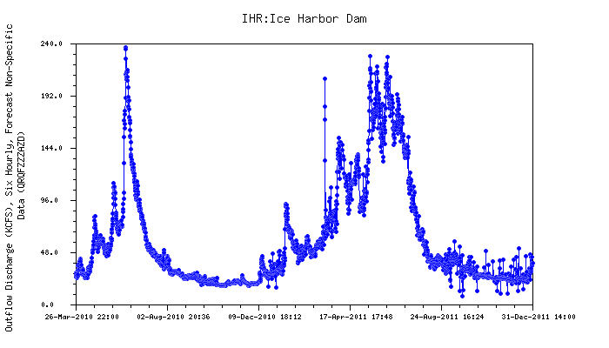

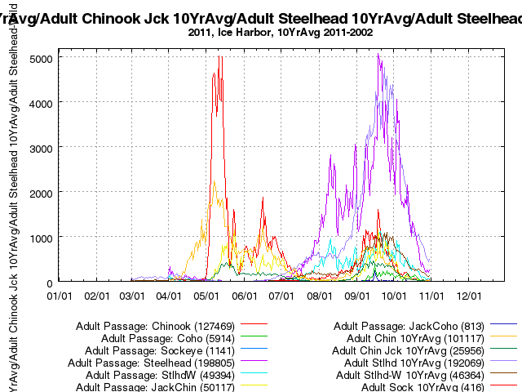

Comments from agencies

-----Original Message-----
From: Trevor Conder - NOAA Federal [mailto:trevor.conder@noaa.gov]
Sent: Wednesday, April 17, 2013 1:38 PM
To: Fone, Kenneth R NWW
Cc: Lorz, Tom
Subject: Re: 13IHR05 Temporary Unit Priority Change (UNCLASSIFIED)

Ken,

I recall this was discussed and approved at FPOM. NOAA supports this priority change as well as fixing this unit to prevent further leakage problems and return this unit to designated FPP priority.

-Trevor

On Wed, Apr 17, 2013 at 1:27 PM, Fone, Kenneth R NWW <Kenneth.R.Fone@usace.army.mil> wrote:

Classification: UNCLASSIFIED
Caveats: NONE

Trevor, Tom,

This coordination form was sent out with the agenda for the last FPOM meeting, but we (Ann, Tammy, and I) are unclear if this was adequately discussed at the meeting. There is no record of it being discussed in the meeting minutes, even though it was on the agenda. Please take a look at the coordination form at your earliest convenience and let me know if you have any concerns.

Thanks,
Ken

-----------------------------------------------------------------

-----Original Message-----
From: Tom Lorz [mailto:lort@critfc.org]
Sent: Wednesday, April 17, 2013 2:25 PM
To: Fone, Kenneth R NWW
Subject: Re: 13IHR05 Temporary Unit Priority Change (UNCLASSIFIED)

I am pretty sure we talked about this, or I am starting to image things. But we are fine with the priority change for now. Will watch and see if we notice any change in adult passage.

tom

>>> "Fone, Kenneth R NWW" <Kenneth.R.Fone@usace.army.mil> 4/17/2013 1:27 PM >>>
Classification: UNCLASSIFIED
Caveats: NONE

Trevor, Tom,

This coordination form was sent out with the agenda for the last FPOM meeting, but we (Ann, Tammy, and I) are unclear if this was adequately discussed at the meeting. There is no record of it being discussed in the meeting minutes, even though it was on the agenda. Please take a look at the coordination form at your earliest convenience and let me know if you have any concerns.

Thanks,
Ken

Final results
Approved. Monitor adult fish passage during the unit 6 priority change period for signs of delay.

Please email or call with questions or concerns.
Thank you,

Mark Plummer
Fisheries Biologist
Ice Harbor Project
509-543-3208

